How Whales Evolved – Evidence and Scientific Arguments

Are whales mammals or fish?

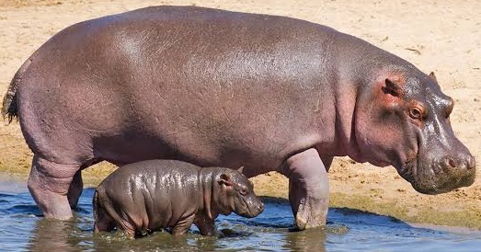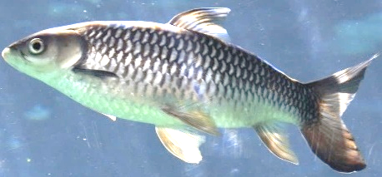
Fish
Mammals
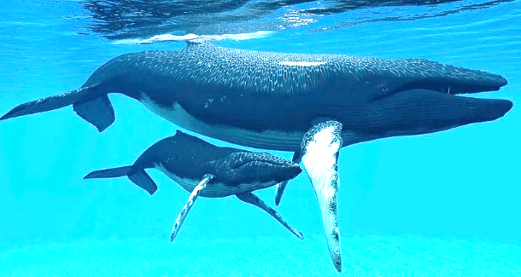
Whales

1. Do whales look more like the mammals ___ or the fish ___?

2. The table below describes some characteristics of mammals, whales, and fish. For each row in the table, draw a connecting line to show whether the whale characteristic is more like the mammal characteristic or the fish characteristic. (The first row shows an example.)

Mammals | Whales | Fish
Four limbs for moving on land | Flippers and a tail for moving in water | Fins and a tail for moving in water
Mammary glands/milk | Mammary glands/milk | No mammary glands/milk
Live birth | Live birth | Lays eggs (with a few exceptions)
Lungs | Lungs | Gills
Heart has four chambers | Heart has four chambers | Heart has two chambers
Warm-blooded | Warm-blooded | Cold-blooded

3. Based on this information, do you think that whales are mammals ___ or fish ___?

Question 5 will ask you to make a scientific argument. To learn why and how to make a scientific argument, view “The Trouble with Cognitive Bias” (https://learn.genetics.utah.edu/content/evolution/bias).

4. Explain why a scientific argument is more persuasive than a quick casual opinion.

5. Fill in this table to make a scientific argument to support your conclusion that whales are mammals ___ or fish ___.

Claim:

Evidence: | Reasoning:

The Evolution of Whales
To learn how whales evolved, view “What is the evidence for evolution?” (https://www.youtube.com/watch?v=lIEoO5KdPvg). This video summarizes evidence concerning the evolution of cetaceans, which include whales, dolphins, and porpoises. These animals share many similarities because of their shared evolutionary history.

6. Describe some of the evidence from comparative anatomy that supports the claim that whales and other cetaceans evolved from land mammals.

If organisms have a similar sequence of nucleotides in their DNA, this indicates that they had a recent shared evolutionary ancestor, so there has been less evolutionary time for mutations to accumulate. For example, the similar sequence of nucleotides in the DNA of whales and hippopotamuses is evidence that they shared a relatively recent evolutionary ancestor.

7. What is the relationship between the sequence of nucleotides in a gene in DNA and the sequence of amino acids in a protein?

The gene for the milk protein, casein, is present in mammals, but not in fish.  The second column of this table gives the percent of amino acids in each animal’s casein that are identical to the sequence of amino acids in whale casein. | Animal | % identical to whale casein
 | Hippopotamus | 83.4%
 | Pig | 68.4%
 | Water buffalo | 66.7%
 | Cow | 63.4%
 | Mouse | 38.4%

8a. Based on this evidence, which is the closest evolutionary relative of whales?
Cow ___ Fish ___ Hippopotamus ___ Mouse ___ Pig ___ Water buffalo ___

8b. Explain your reasoning.

This figure summarizes scientists’ current understanding of cetacean evolutionary history. The long horizontal arrows indicate animals that are alive today; the other animals shown are based on fossil evidence and are extinct. The labels on the left describe important characteristics of the various groups.
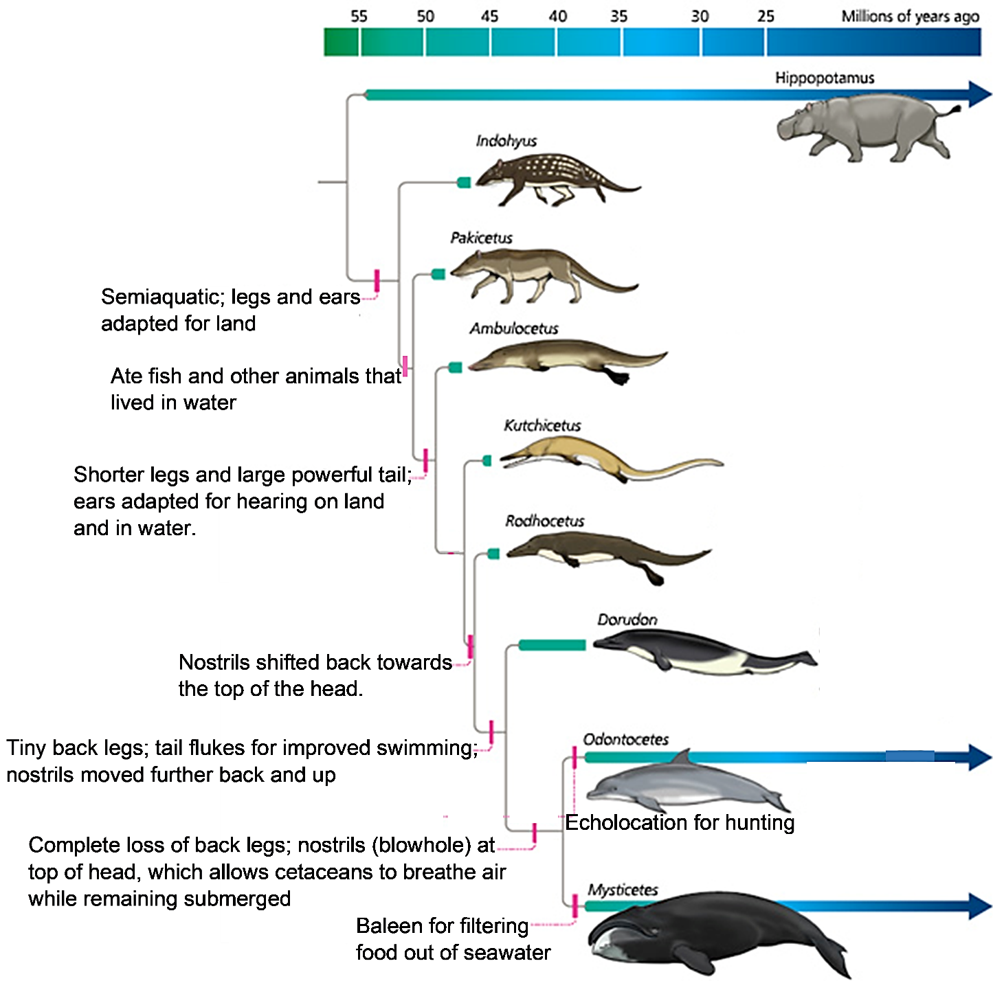
9a. In the above figure, underline the descriptions of the legs at different times during the
evolution of cetaceans.

9b. The figure to the right shows a whale’s tail flukes and how the tail moves to propel the whale forward as it swims. In the above figure, circle the first appearance of tail flukes during the evolution of cetaceans.

9c. Explain how the evolutionary changes in the back legs and
tail helped cetaceans become better adapted for living in water.

This figure shows several stages in the early development of a cetacean. (The length of the embryo more than doubles as the embryo develops through these stages.)
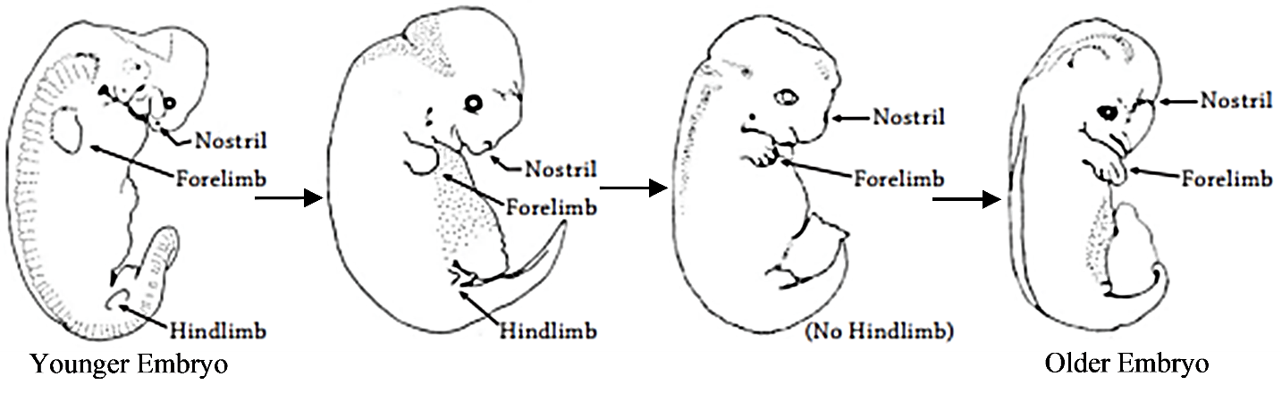
10. Use the information in this figure to give examples that support the following conclusion.
Embryos often have some characteristics of evolutionary ancestors that are absent in the adults. Often, later stages of embryological development are modified to produce characteristics that evolved more recently.

- Homologous structures (homologies) are characteristics that are similar due to inheritance from shared evolutionary ancestors. Homologies are used to group organisms in biological categories such as mammals or fish.
- Analogous structures (analogies) are similar characteristics that evolved independently as adaptations to similar environments and functions. For example, the wings of flying insects, birds and bats evolved independently, but they have generally similar shapes.
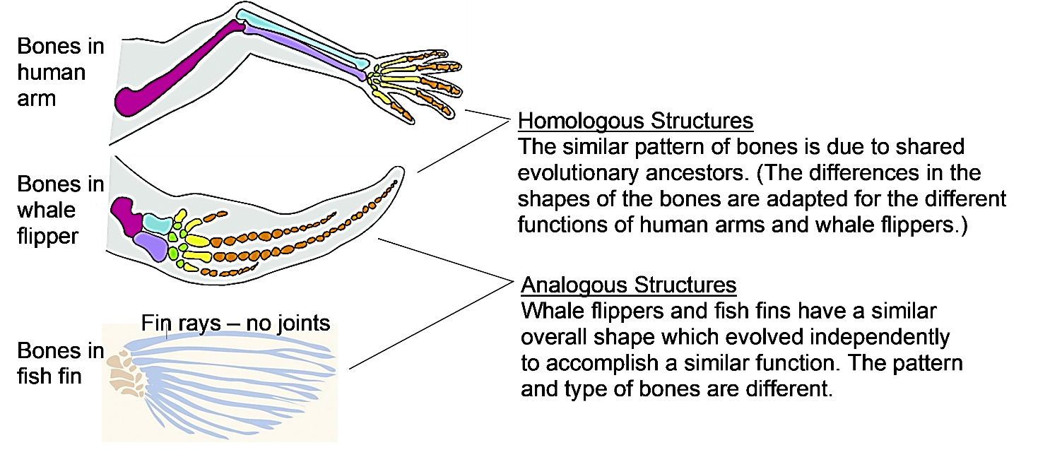
11a. Do you think that the similar overall body shape of whales and fish is due to:
inheritance from shared ancestors (homology) ___ or
independent evolution of similar characteristics (analogy) ___?

11b. Explain your reasoning.

12. Complete this table to present a scientific argument for the claim that:
“Whales and other cetaceans are the evolutionary descendants of ancestral mammals that lived on land.”

Evidence | Reasoning
Comparative Anatomy

Molecular

Fossils

Embryology and Development

By Dr. Ingrid Waldron, Dept Biology, University of Pennsylvania. © 2022. A Word file and Teacher Notes with instructional suggestions and biology background are available at https://serendipstudio.org/exchange/bioactivities/whale evolution.

